# TECHNICAL DEVELOPMENT CENTRE

# TECHNICAL DEVELOPMENT CENTER

## PCB Assembly

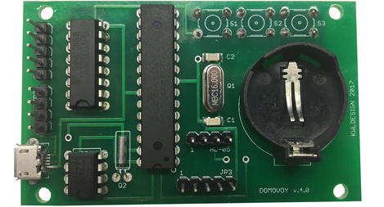

Before mounting the Atmega328P microcontroller, you must flash the bootloader before the feeder can be programmed using the Arduino IDE. It can be flashed with a special programmer, or with an Arduino Board. How to do this, see the Arduino website at the following links:

* [Arduino as ISP and Arduino Bootloaders](https://www.arduino.cc/en/Tutorial/ArduinoISP)
* [Building an Arduino on a Breadboard](https://www.arduino.cc/en/Main/Standalone)

A circuit diagram of the feeder "DOMOVOY":

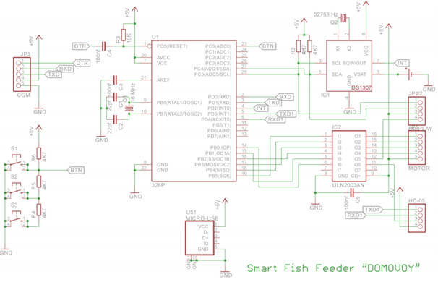

|  |  |  |
| --- | --- | --- |
| **Debice** | **Name** | **Value** |
| Capacitors 1206 | C1, C2 | 22 pF |
| Capacitors 1206 | C3, C4, C5 | 100 nF |
| Resistors 1206 | R1, R2, R4, R5, R6 | 4K7 |
| Resistor 1206 | R3 | 10 K |
| Chip RTC | IC1 | DS1307 |
| Stepper motor driver | IC2 | ULN2003A |
| Crystal | Q1 | 16 MHz |
| Crystal | Q2 | 32768 Hz |
| Microcontroller | U1 | Atmega328P-PU |
| Battery holder | U2 | CR2032 Holder |
| Connector | JP1, JP3 | 5 pin header |
| Connector | JP2, HC-05 | 4 pin heade |
| Buttons | S1, S2, S3 | Omron Switch |
| Connector | U$1 | Micro-USB |

Parts required for the assembly of circuit boards:

|  |  |
| --- | --- |
|  |  |
| Prepare parts for assembly. | First install the smd components. |
|  |  |
| Install the connector and capacitors on the back of the board. | Install the remaining components. |

|  |  |
| --- | --- |
|  |  |
| Assembled board, top side. | Assembled Board, bottom side |
|  |  |
| Use the USB-UART programmer to flash the controller. | Programming device connection diagram. |